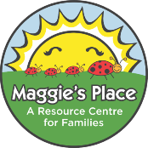
Frozen Yogurt Fruit Bark
Ingredients:
3 cup plain yogurt (1 container)
3 tsp maple syrup
1 ½ cups chosen fruit

Method:
- Wash fruit if it is fresh.
- Place parchment paper or silicone sheet on in cake pan/use papers in muffin tins.
- Mix yogurt and maple syrup in bowl.
- Pour the mixture out onto whatever pan you are using. Allow to spread out to cover pan.
- Sprinkle the fruit over top.
- Freeze for 3-4 hours.
- Break into pieces and enjoy, or store in container in freezer.

