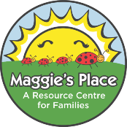
Granola Bars

Ingredients:
2 cups whole wheat flour
1 cup rolled oats
1 tsp baking soda
1 tsp cinnamon
½ nutmeg
1 cup brown sugar or honey
1 cup melted margarine
2 eggs
1 tsp vanilla
1 cup chocolate chips

Directions:
1. Mix together all dry ingredients. Add in melted margarine, eggs, vanilla and honey if using. Stir well. Add chocolate chips. Mix.
2. Press into cookie sheet or 2 squares cake pans. Bake at 375 degrees F for 10-15 minutes.
3. Cut into bars when cooled.

